Elemental Fox

Game Description
Elemental Fox is a 2D platformer and puzzle game where the player needs to resolve puzzles and avoid enemies by using different forms and powers.
The player can change the appearance and the abilities of the character during the gameplay by interacting with an elemental obelisk to complete the level.
The player can access 5 elemental forms (fire, water, earth, air and neutral) each element interacts in a different way with the traps and mechanisms, also every element has an active and a passive ability:
- Passive ability: Will interact with the environment just by being in a given place
- Active ability: Will be used when the player presses “E”
The player can also carry one single object to complete the puzzle while he caries an object the player can not use his active skill.
While the majority of the traps and mechanisms will either permit the player to pass, kill him or make him lose some progress, some of them may reveal hidden paths or present different challenges. The traps and mechanisms can also be specific for an element or have different variants for every element.
Enemies will need to be either avoided or used as steeping stones for the player to progress, with the combat being non existent instead the player needs to outsmart or completely avoid the enemies.

Character

General

Description
The general aspect of the character is that of a fox with two tails, with a black patch of fur at the end of each tail.
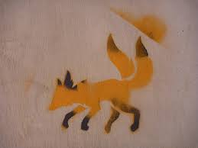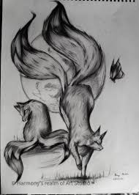

The character will have 5 forms with every form having different sprites, animations, stats and abilities.
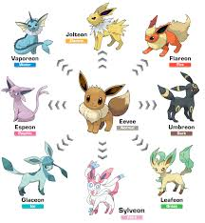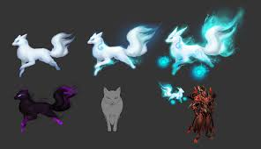

Animations
All animations will be split between body animation and tail animation, that can be played independent from each-other depending on the inputs from the player and the environment.

Stats
The world is formed from small cubes and all the measurements will be in rapport with the cubes, for an easier understanding every cube will have the dimensions 1m x 1m.
The character hit box dimensions will be 0.9 m in length and 0.85 m in height, with the hole sprite taking almost a 2m x 2m in diameter.

Red: standard block 1x1
Blue: character sprite 2x2

Stats:
- Walk – 6m/s
- Jump – 4 m

Elemental Ability
Elemental ability is activated when the player presses “E”

Elemental Passive

This is a unique passive for every form, it does not require player action.

Pre-neutral

Description
Pre-Neutral form should be identical with the Neutral form with the exception that the player will not have access to an elemental ability and as for the visual part the player will have only one tail.

Neutral

Description
In neutral form the sprite will be that of a red fox with two tails, black fur present at the end of each tail, on the lower part of each foot and on the ears.
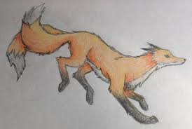

Animations:
- Walk – a running animation with the tails and ears flowing in the wind
- Jump – an animation where the fox quickly crouches ant then jumps
- Fall – an animation where the fox falls
- Idle – an animation where the fox stays idle
- Interact – (body only) an animation where the fox interacts with the elements of the environment, the fox interacts using her nose.
- Elemental ability – tail grab (tails only) an animation where the tails grab any object in front of the character

Elemental Ability – Tail grab
The player has the ability to move small objects around the map. The objects will be picked when the player is near them, held behind the player and placed where the character is in the moment of the button press.

Fire

Description
In fire form the character colors change to a fiery red, with flames present on the tails and on the ears, with the sprites giving an agile aspect.

Fire fox is agile and powerful, firing a fire ball at the targets

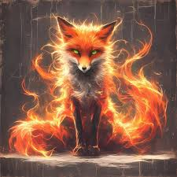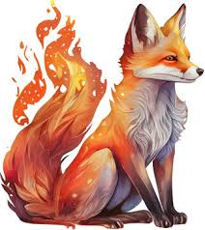

Animations:
- Walk – a running animation with the tails and ears flowing in the wind (25% increase in the animation speed)
- Jump – an animation where the fox quickly crouches and then jumps
- Fall – an animation where the fox falls
- Idle – an animation where the fox stays idle
- Interact – (body only) an animation where the fox interacts with the elements of the environment, the fox interacts using her nose.
- Elemental ability (animation only for tails) – the tails flick towards the front of the character

Elemental Ability – Fire ball
The player shoots a fire ball from his tails, at the player level. The fire ball moves is the direction that the character is faces and moves at twice the speed of the character (fire form).
A fire ball moves until it hits a wall or a mechanism, if it hits a mechanism then it will activate it.

Elemental Passive

In fire form it has the ability to completely nullify any damage received from fire elements.

Water

Description
In water form the basis tails are switch with fish tails that end in a fin, with the tails keeping the same length. The color of the body changes to a blue/dark blue, with water droplets permanently falling from the body and droopy ears giving the player the feeling that the character can melt at any time.

Water fox is nimble and can reach places that are impossible to reach to any other form, it can climb vertical walls

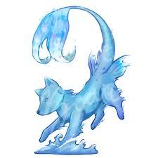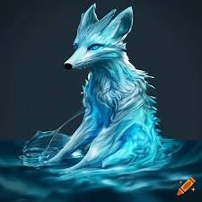

Animations:
- Walk – a running animation with the tails and ears flowing in the wind
- Jump – an animation where the fox quickly crouches and then jumps
- Fall – an animation where the fox falls
- Idle – an animation where the fox stays idle
- Interact – (body only) an animation where the fox interacts with the elements of the environment, the fox interacts using her nose.
- Elemental power – (body only) an animation where the character transforms the legs in a snail like foot formed from foam and bobbles.
- Elemental ability – (body only with the tails missing) a blob like sprite with half of the normal height, and with only the face as a distinguishable feature.

Elemental Ability – Water blessing
Sprinkles water up to 2 blocks in front of the player activating any mechanisms present there.

Elemental Passive

In water form the player has the ability to swim through water and ignore damage from any water related trap.

Wind

Description
In wind form the character has a floaty appearance similarly to that of a ghost, with the lower part of the legs being translucent giving the feeling that the character floats above the ground, and the tails missing the base making them float near the character.

Wind fox is very light having the ability to give herself a boost mid jump or on terrain and can be moved around by the objects

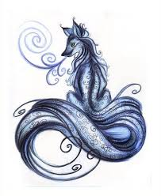

Animations:
- Walk – a running animation with the tails and ears flowing in the wind
- Jump – an animation where the fox quickly crouches and then jumps
- Fall – an animation where the fox falls
- Idle – an animation where the fox stays idle
- Interact – (body only) an animation where the fox interacts with the elements of the environment, the fox interacts using her nose.
- Elemental ability (animation only for tails) – the fox spins her tails quickly launching a projectile up.

Elemental Ability – Tornado
Creates a tornado 1 block in front of the player that can activate mechanisms and lift up certain blocks.

Elemental Passive

The player will not take damage from spikes.

Earth

Description
In earth form the character presents scales across the body, with the majority concentrated around the shoulder, rib cage and on the head forming a helmet, making the character appear hard and sturdy as a rock, but also a slow mover. The tails become covered in stone taking the aspect of a mace.

Earth fox is slow and sturdy, having the ability to ignore damage from specific traps and to move heavy objects around or break walls.

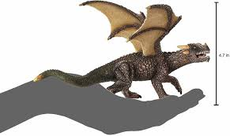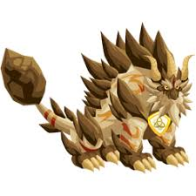

Animations:
- Walk – a running animation with the tails and ears flowing in the wind
- Jump – an animation where the fox quickly crouches and then jumps
- Fall – an animation where the fox falls needs a heavier feel as the character is more heavy
- Idle – an animation where the fox stays idle
- Interact – (body only) an animation where the fox interacts with the elements of the environment, the fox interacts using her nose.
- Elemental ability (animation only for tails)

Elemental Ability – Boulder push
Once activated the player can push heavy objects around the map.

Elemental Passive

In this form the player is invulnerable to crushing blocks.

State machine
State machine controls both the animation and the behavior of the character.

The character is split in 2 parts the Tails and the Body, witch can have different states, while some states are applied for both, while other states can be applied separately from each-other.

The character uses 2 concurrent state machines: Elemental State Machine and an Action State Machine.
Action State Machine is used to determine what are the actions of the character such as Idle/Walk/Jump.
Elemental State Machine is used to determine how the character looks, interacts with the environment and what passive/active is activated at any moment.

- Idle state is applied to both parts unless an Elemental ability state is active
- Walk state is applied to both parts unless an Elemental ability state is active
- Interact state is applied to both parts unless an Elemental ability state is active
- Jump state is applied to both parts unless an Elemental ability state is active
- Fall state is applied to both parts unless an Elemental ability state is active
- Hurt state is applied to the hole body, is activated when the player gets hurt.
- Elemental ability – Neutral state is applied only to the tails and overwrites any other states, ends only when the player selects elemental ability again
- Elemental ability – Fire state is applied only to the tails and overwrites any other states, ends after the animation finishes playing.
- Elemental ability – Water state is applied to the body and tails and overwrites any other states, ends when the player selects elemental ability again
- Elemental ability – Wind state is applied to the tails and body and overwrites any other states, ends after the animation finishes playing.
- Elemental ability – Earth state is applied to the tails and overwrites any other states, ends when the player selects elemental ability again or jumps.

Action State Machine flow:

- Idle
  - Walk
  - Interact
  - Jump
  - Fall
  - Hurt
  - Elemental ability – Neutral
  - Elemental ability – Fire
  - Elemental ability – Water
  - Elemental ability – Wind
  - Elemental ability – Earth
- Walk
  - Idle
  - Interact
  - Jump
  - Fall
  - Hurt
  - Elemental ability – Neutral
  - Elemental ability – Fire
  - Elemental ability – Water
  - Elemental ability – Wind
  - Elemental ability – Earth
  - Elemental power – Water
- Interact
  - Idle
  - Walk
  - Hurt
- Jump
  - Fall
  - Hurt
  - Elemental ability – Neutral
  - Elemental ability – Fire
  - Elemental ability – Wind
  - Elemental power – Water
- Fall
  - Idle
  - Walk
  - Hurt
  - Elemental ability – Neutral
  - Elemental ability – Fire
  - Elemental ability – Wind
  - Elemental power – Water
- Elemental ability – Neutral
  - Idle
  - Walk
  - Interact
  - Jump
  - Hurt
- Elemental ability – Fire
  - Idle
  - Walk
  - Interact
  - Jump
  - Hurt
- Elemental ability – Water
  - Idle
  - Walk
  - Hurt
- Elemental ability – Wind
  - Idle
  - Walk
  - Interact
  - Hurt
- Elemental ability – Earth
  - Idle
  - Walk
  - Interact
  - Jump
  - Hurt
- Elemental Power – Water
  - Walk
  - Jump
  - Fall
  - Hurt
- Hurt

Elemental State Machine flow:

- Neutral
  - Fire
  - Water
  - Wind
  - Earth
- Fire
  - Neutral
  - Water
  - Wind
  - Earth
- Water
  - Neutral
  - Fire
  - Wind
  - Earth
- Wind
  - Neutral
  - Fire
  - Water
  - Earth
- Earth
  - Neutral
  - Fire
  - Water
  - Wind

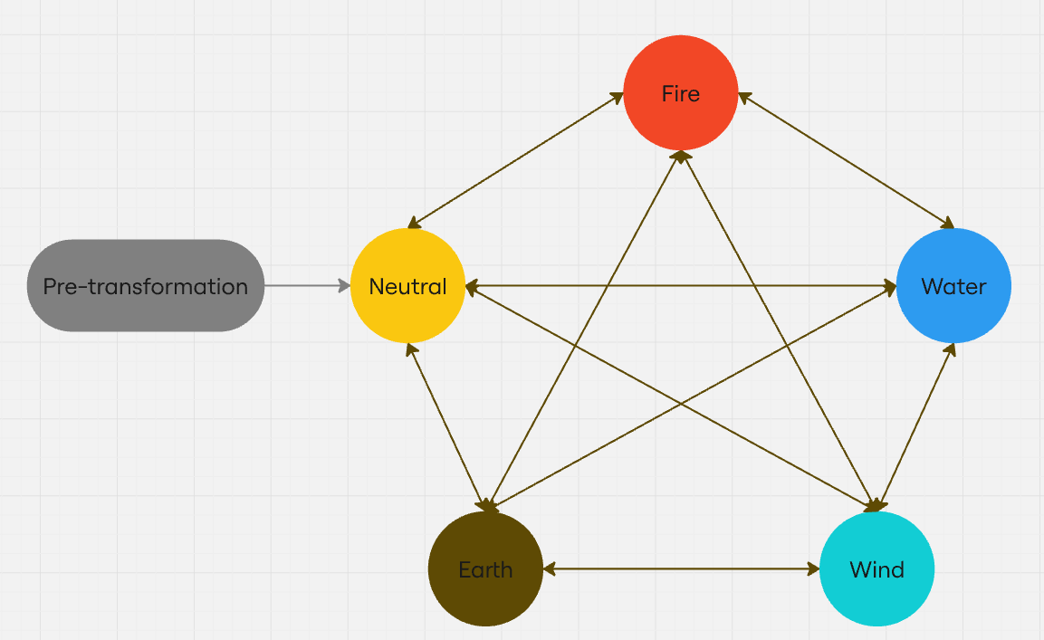

Controls

Mouse and Keyboard
A/D – Left/Right
W/S - Up/Down
Space – Jump
E – Interact / Elemental ability
Esc – Menu

Controller
Left stick left/right – Left/Right
Left stick up/down - Up/Down
A – Jump
Y – Interact / Elemental ability
B – Menu

Camera

General
Camera will remains static all the time capturing the hole level at any time.

Combat
Combat will be non-existent as the enemies present will act as traps/mechanisms that the player needs to avoid or use the enemies as steeping stones to progress through the level.

Health
The player will have only one life in any form, that can be lost when the character hits any kind of trap. Once the player has lost his life, the level ends and a defeat screen is presented.

Environment
Every level will have a theme that centers around the elements necessary to complete the level, and a central theme that spans across several levels.

Blocks, traps and mechanisms will have elemental variants that will have different interactions with the player and the environment.

A majority of blocks and traps can be connected to mechanisms to change their properties.

Blocks
Blocks represents a part of the environment on witch the player can walk and navigate without to many risks.

Platform
A block where the player can pass through it by jumping up or by holding down when standing on the block.

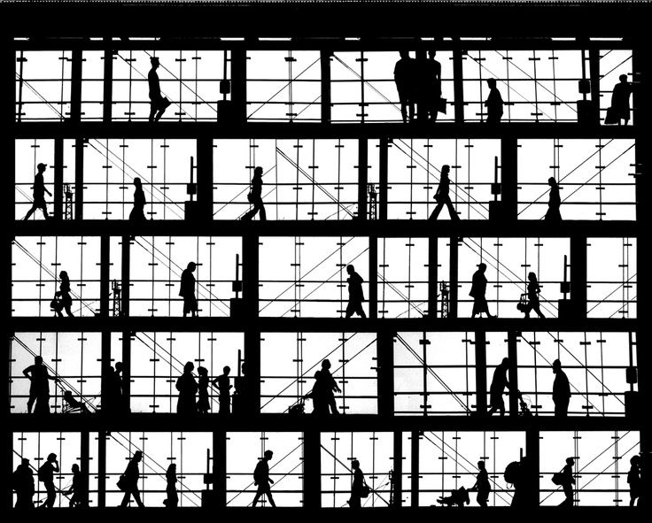

Plant Block

Fire: Acts as a barrier until the player burns it using the fire ability, the fire will spread to nearby blocks with the ability to be burnt.
Water: Creates 3 more blocks in a pre-set position when the water ability is used on it.

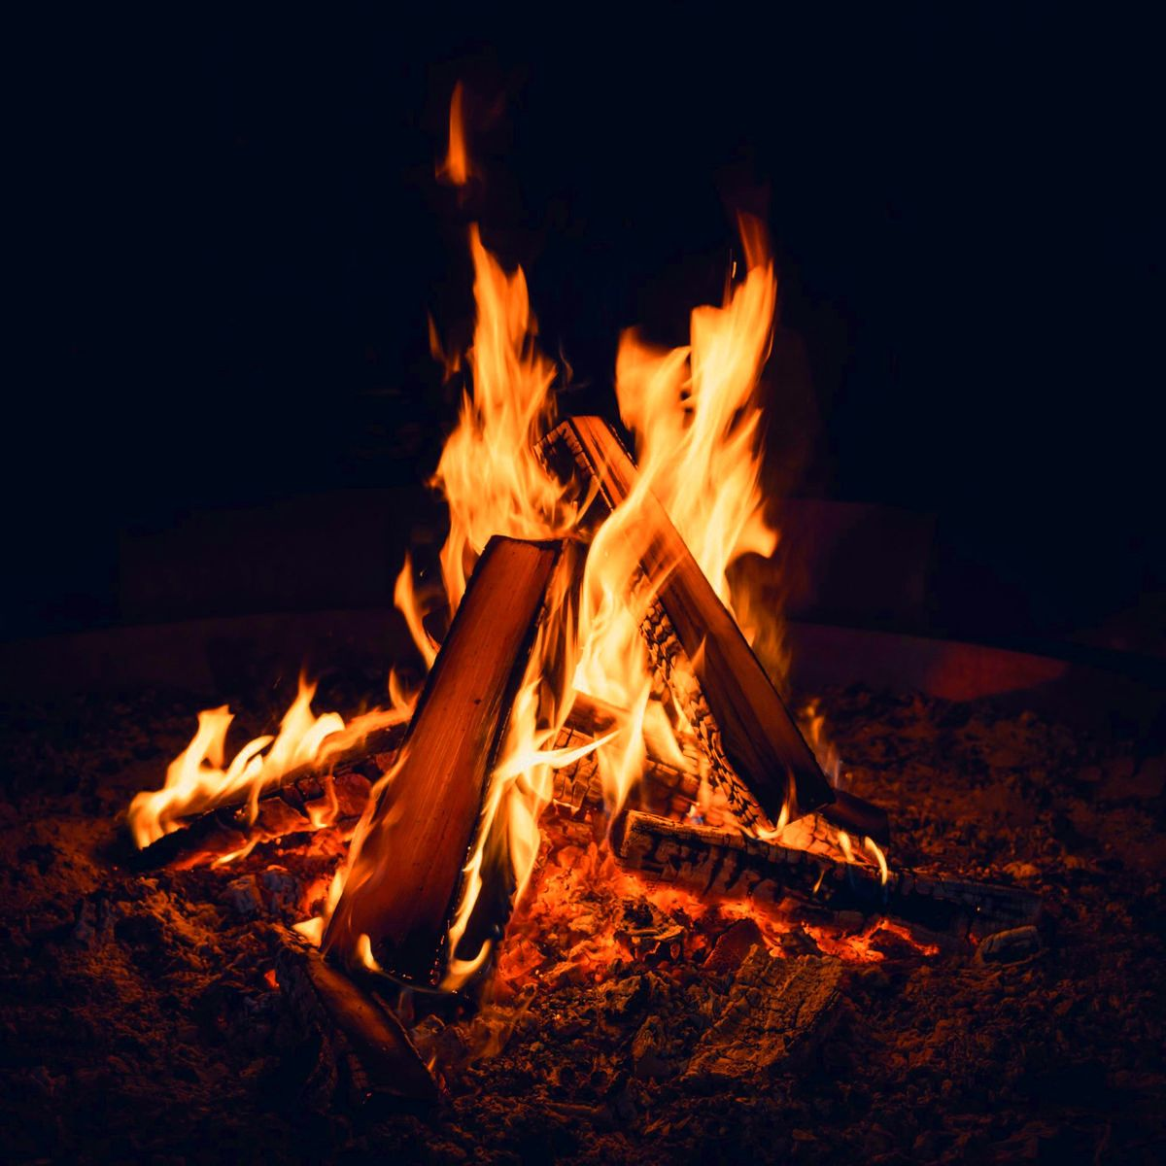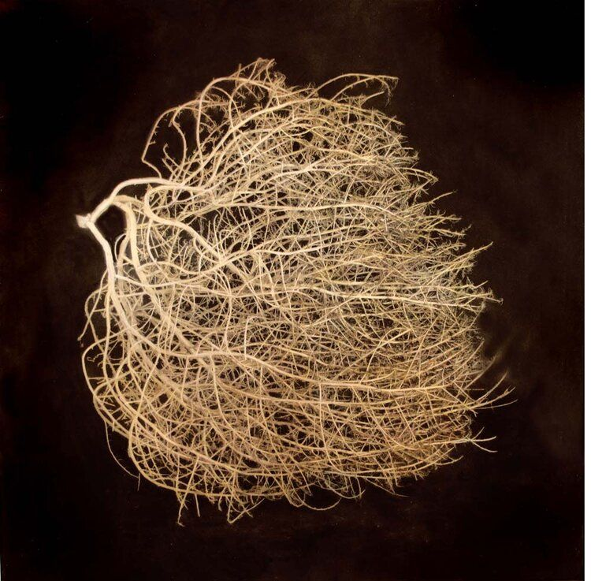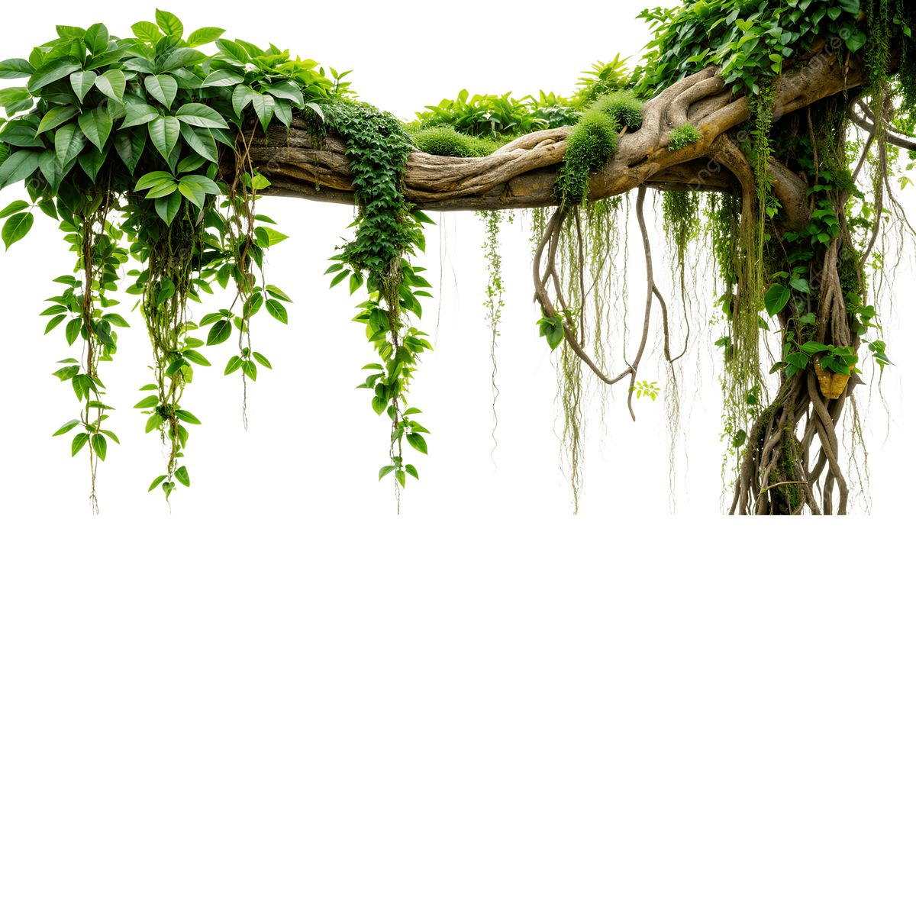

Moving block
Moving block will move between a set of points on either X axis or Z axis.

Activated – Moving Block
This block will be stationary until it receives a signal then it will start moving between the pre-set points.
State machine:
- Stopped – Is the part in witch the block does not move.
- Activated – After the block receives a signal it will start moving between the pre-set points.

Crumbling block
This block will allow the player to stay on it only for a short duration after that the block will disappear making the player fall, the block will appear again after a time
Will not disappear when wind form interacts with it.
State machine:
  - Idle – waiting for the player to walk on the block
  - Crumbling countdown – after the player touches the block for the first time a countdown starts.
  - Crumbling – the countdown has finish, the block becomes invisible and the player falls through it.
  - Re-spawn countdown – a countdown that starts after the block disappears.
  - Re-spawn – after the countdown has finish, the block reapers and the block becomes tangible again.

Crate
The crate is a block that can be easily moved by the player in Earth state, can also be moved by other objects in the world.

Mirror block
Fire: A block that can deflect a fireball by 90 degrees.
Earth: It can be moved by the player.

Activate mirror block
Can be moved by a mechanism and will deflect fireballs.

Floating mirror block
Fire: A floating block that can deflect a fireball by 90 degrees.
Wind: Can be pushed upwards or downwards by the wind ability.

Flower pot
Water: Creates a plant witch will act as a platform so that the player can climb up.
Earth: Can be moved by earth ability

Small fan
Wind: Can be moved upwards using the wind ability:
Earth: Can be moved by earth ability:

Sprinkler
Periodically drips water .
Water: Creates a column of water that can be used as a stepping stone.
Wind: Rises the block and spreads the water 3 blocks in each direction.

Traps

Traps will hurt the player on contact, and the player needs to deactivate ( if possible) or avoid all together.

Spike
Spikes are a fixed trap that will hurt the player
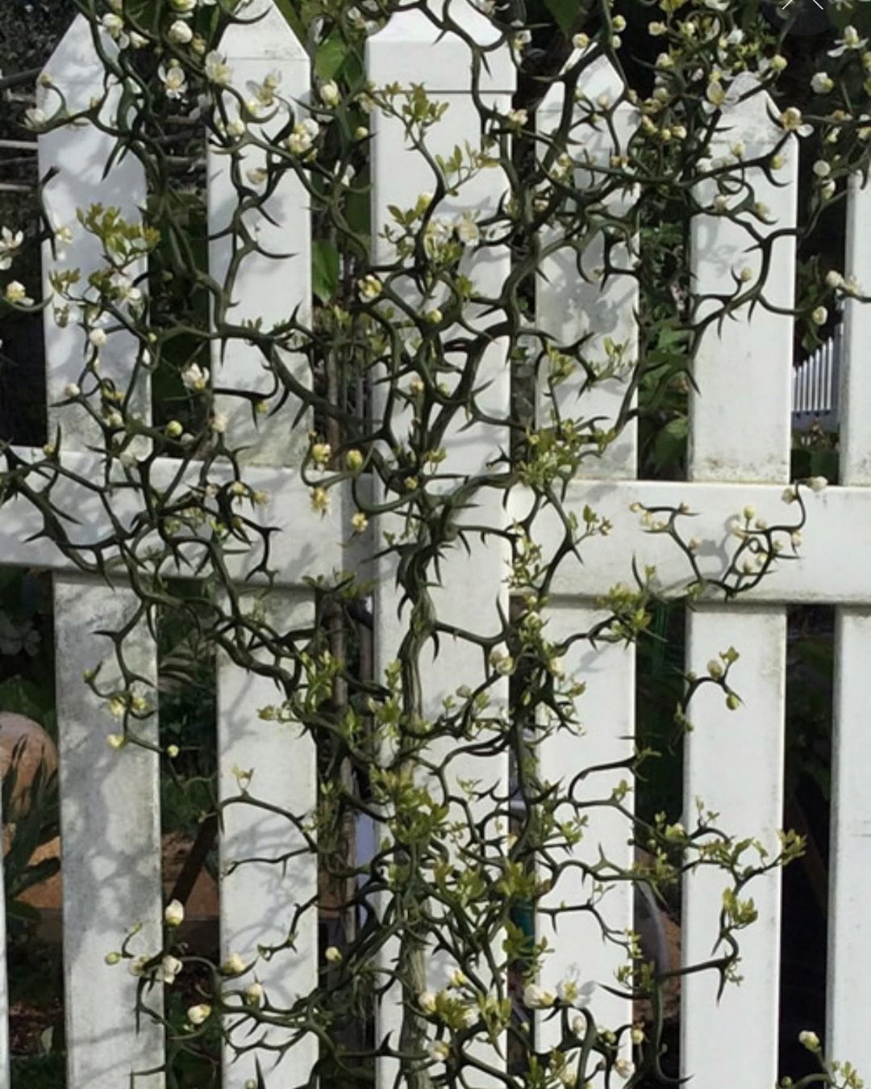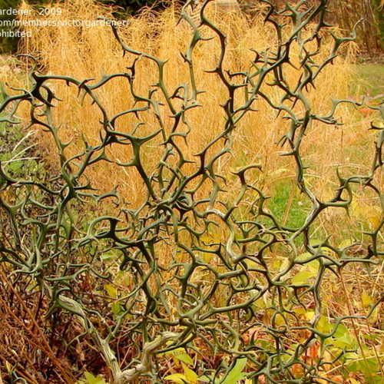

Retracting spikes
Retracting spikes are a variant of spikes that have two states an active state that has the spikes raised and will hurt the player and an off state that will not hurt the player.

Lava
A block that damages all forms except fire form.

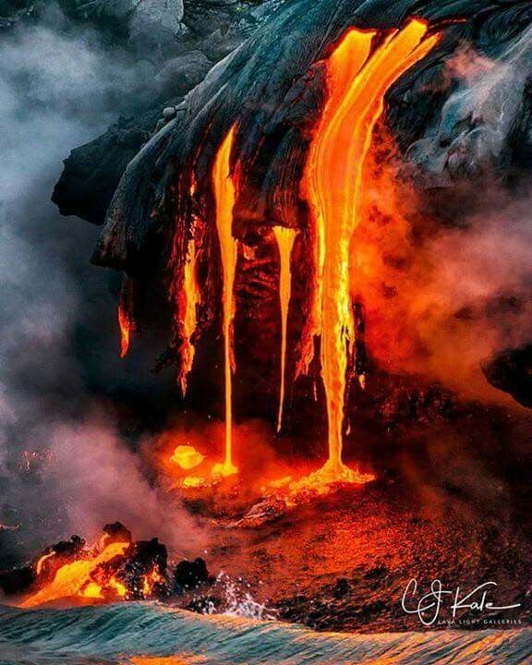

Shooting arrow
A block that shoots an arrow every couple of seconds.

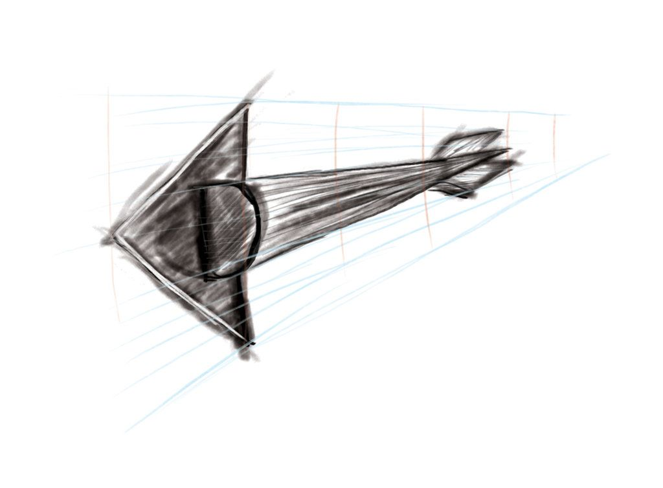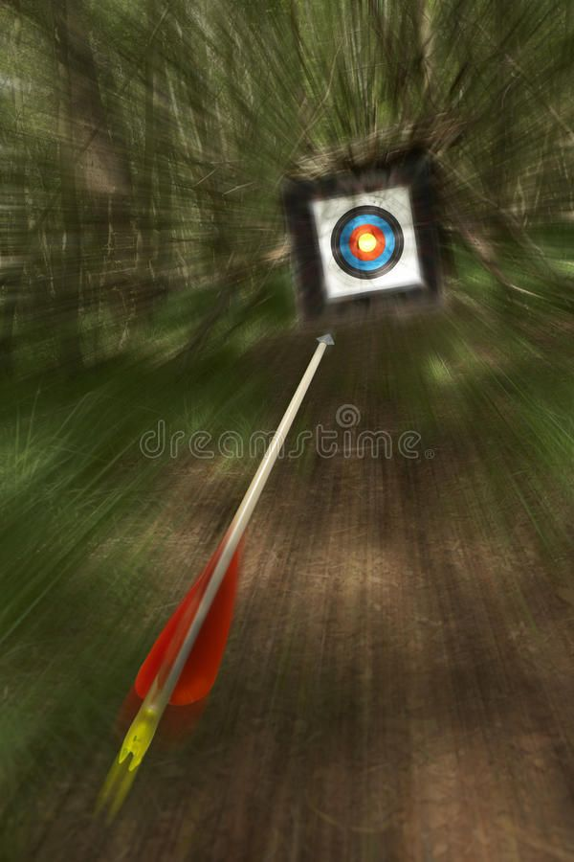

Activated Shooting arrow
A block that shoots an arrow when activated.

Saw
The saw is a moving trap between 2 points that will hurt the player on contact.

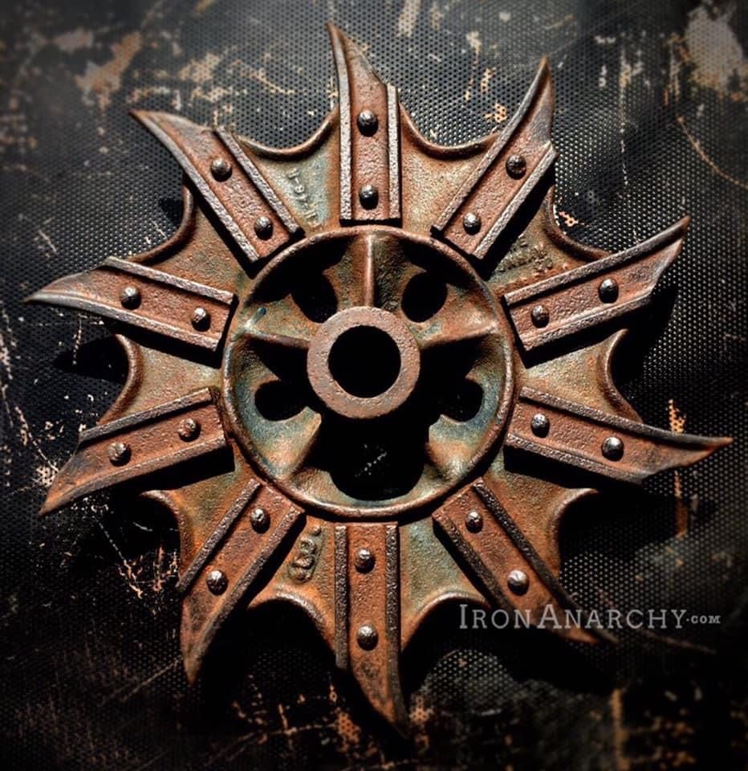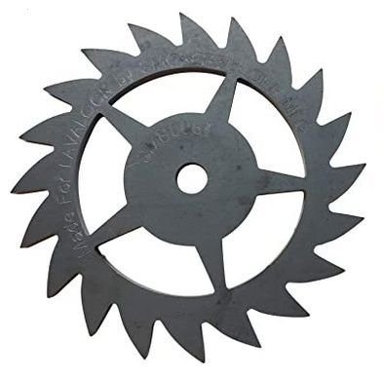

Crushing block
A block that moves between 2 points crushing the player if he is between a wall and the trap, also will move any entity that is in front of the block.

Water
A block only water form can pass through the rest will drown.

Shooting Fire ball
A fire ball that will be shot after a specific time, can activate all Fire related traps.

Mechanisms
Mechanisms are all the objects with which the player can interact and change the environment.

Lever
Lever is a mechanism that has 2 states ON/OFF in ON state sends a signal that will switch the state of the intended objects to active, in OFF state sends a signal that switches the state of the intended object to inactive.

Target
The target acts like a lever, but it can be activated by a fireball from fire form, once activated sends a signal to the desired target.

Detector
This mechanism sits in the background and can not be touched. Sends a signal when something passes in front of it such as (fireballs, the player, or a block moving in front)

Pressure plate
The pressure plate is a mechanism that sends a signal once an object is above itself and a signal when an object moves from the block.

Water valve

A block positioned in the background that will detect when a water ability is used in front of him.

Closed Fan
Will send a signal wend a wind current is present in front of the fan, this mechanism will be in the background and the player can not directly interact with it.

Essentials

Spawn point
Spawn point is the place where the game will spawn the character at the beginning of the level, will try to spawn Neutral type if it is not specified otherwise

End point
Marks the level as being completed successfully once the player reaches it.

Elemental Obelisk
Elemental obelisk is an intractable non tangible block from witch the player can change his form, all elemental obelisks will have a preset element.
Elemental obelisks can have 5 different forms one for each element, once activated it will send a signal towards the player that will change the element of the player.

State machine:
- Idle
- Interacted
- Sending signal (sends a different signal towards the player based on the elemental form)
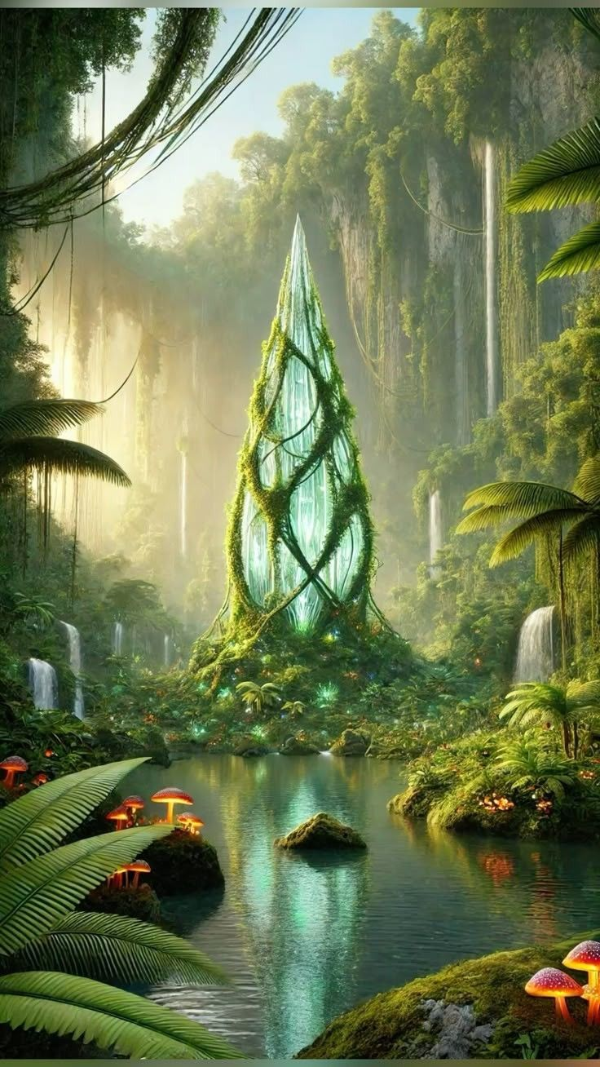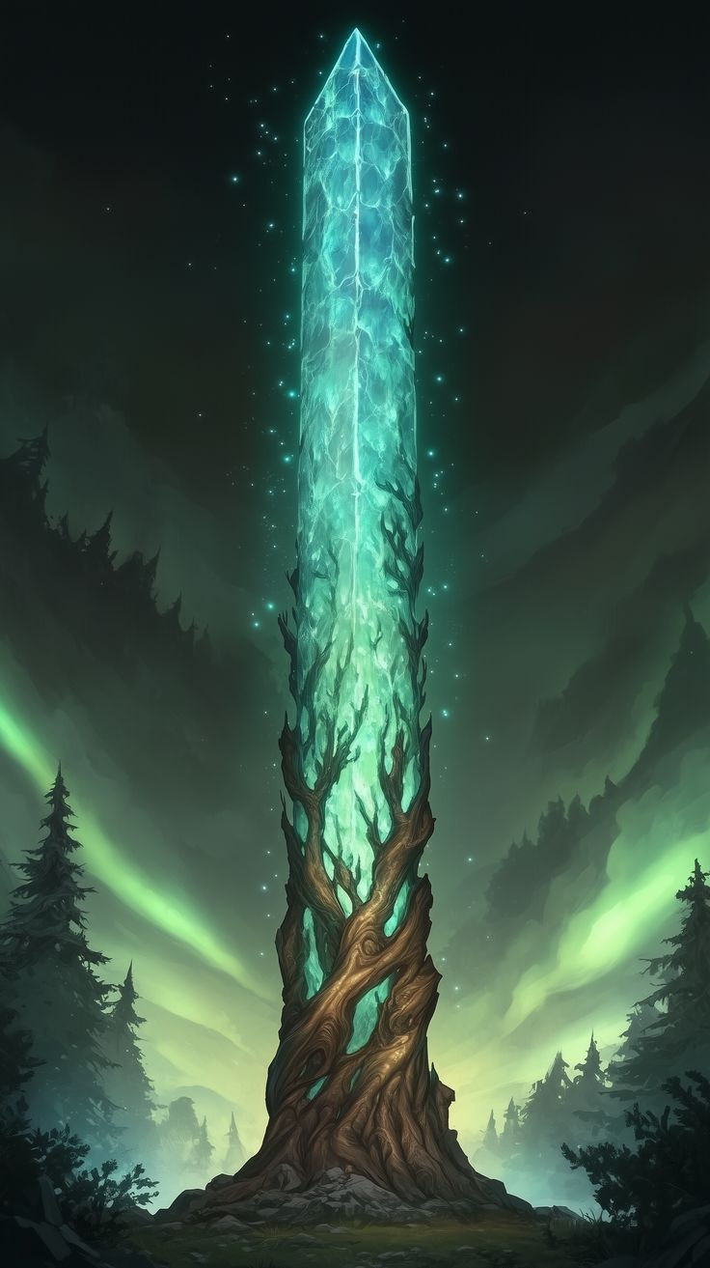

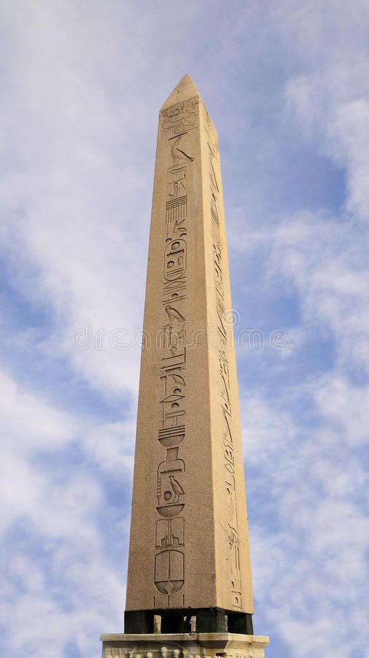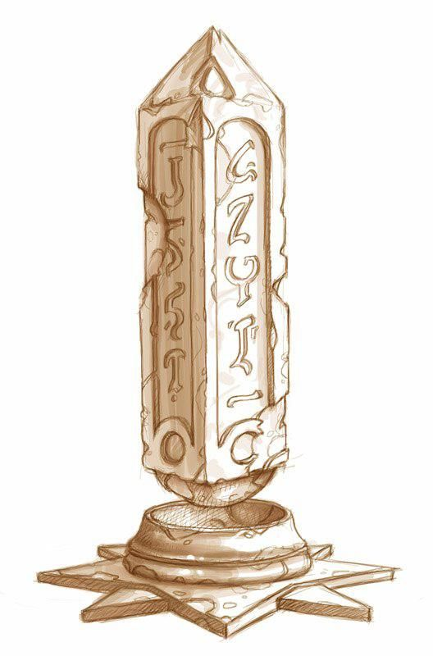

Info Stone
Info stones will be scattered at key points around the level giving the player critical information’s, info stones should have basic drawings to signify key input for specific actions, an action or a result.

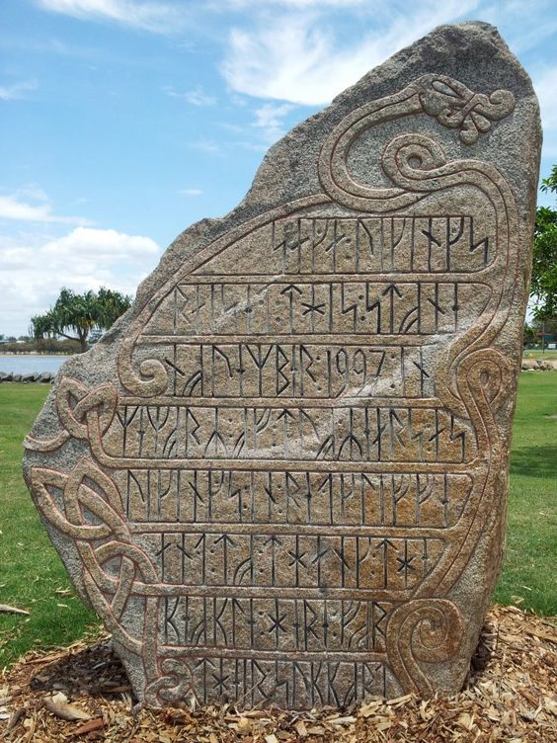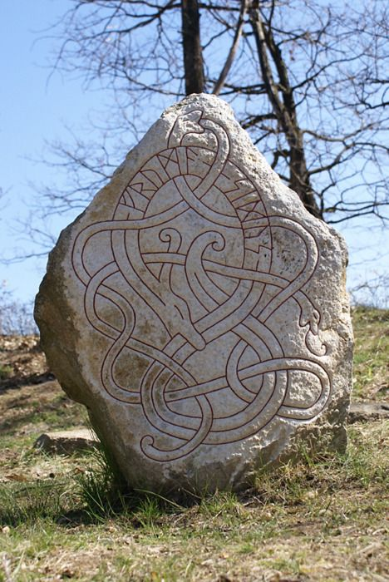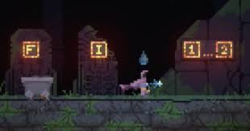

Levels
Every level will have a start position and a finish position, the level will have a fix position with a finite space, with a puzzle that needs to be completed before finishing the level
First 5 levels will focus only on one element with the next levels focusing on combining 2 or more elements.

Level 1
Will focus on movement, with two info stones one for left/right movement and one for jump right before a spike trap. The trap should be represented by natural thorns grout.
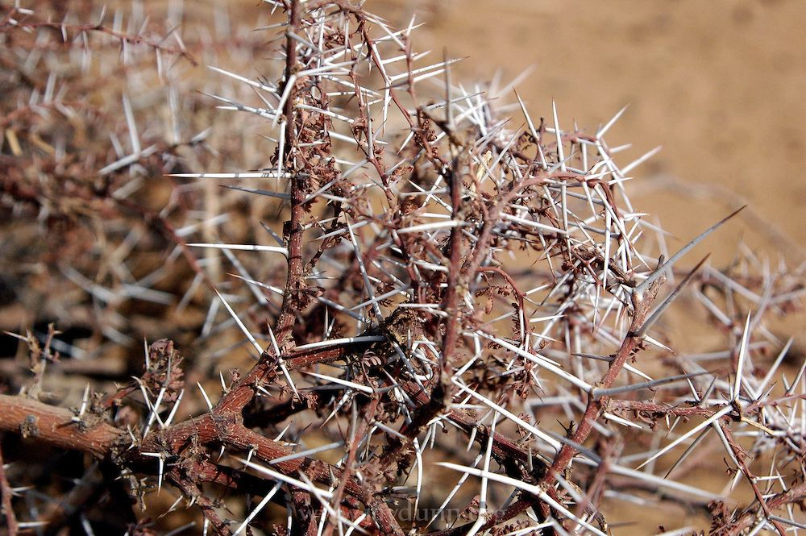

The player should be walking through plains biome with a ruined castle present in the background.

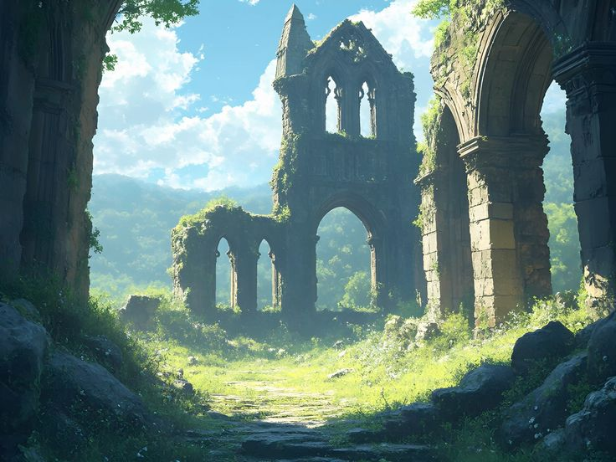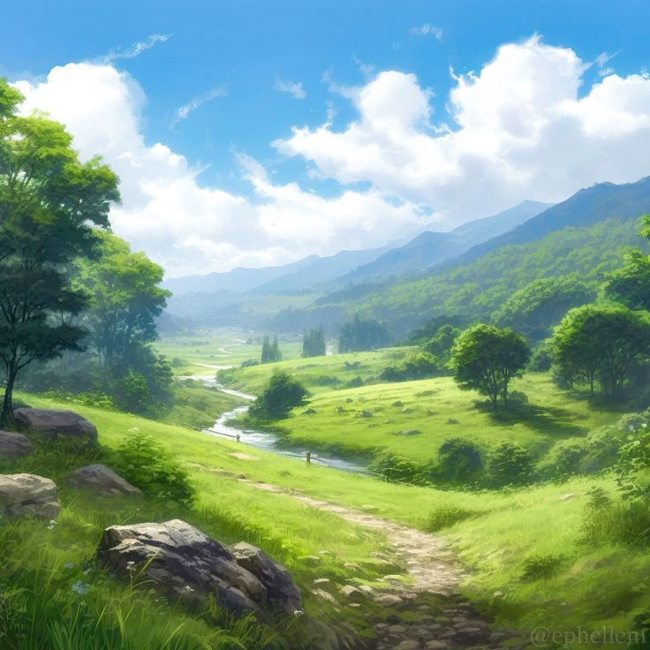
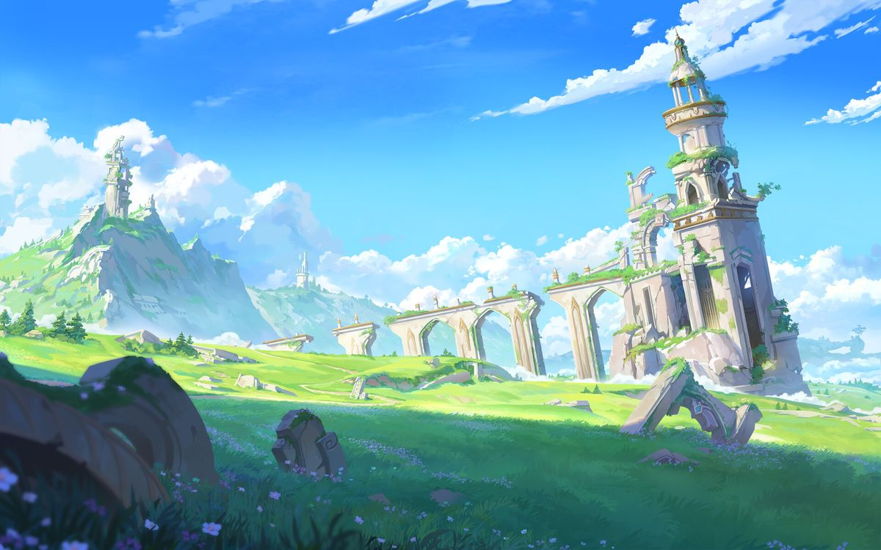

Level 2
Focuses on the elemental transformation, present in the middle of the map is a temple like structure mostly destroyed on the left side, with a stone platform in the middle surrounded by all obelisks types. When interacting with the obelisk a special animation where the player transforms will be player and the player will be transformed in fire form. An info stone will be present right before the obelisk presenting the interact button.
A second info stone will be present right before the end, and it will show what button can be pressed to use the elemental ability.
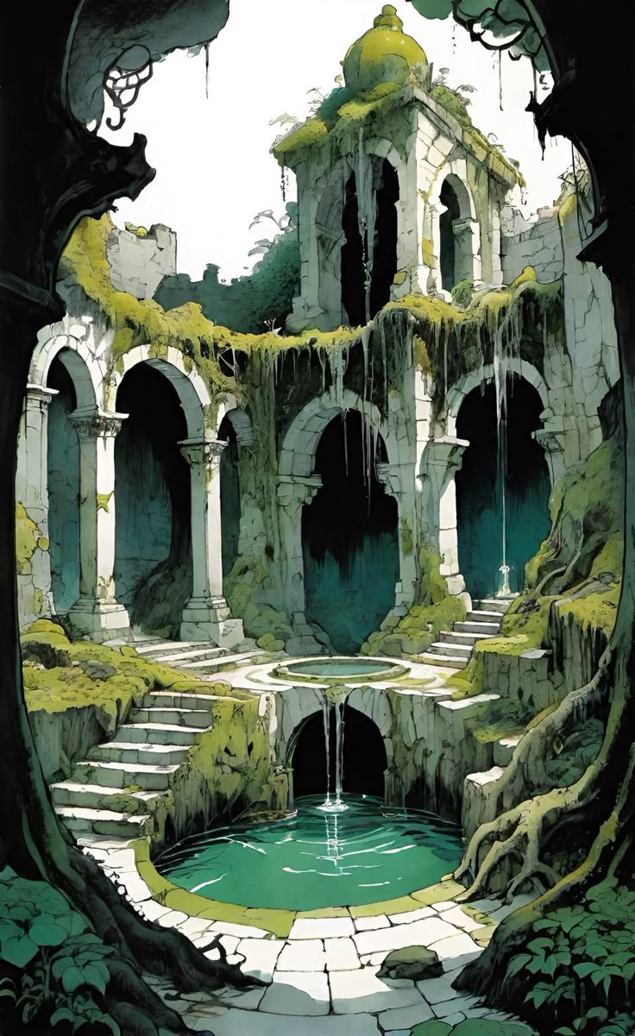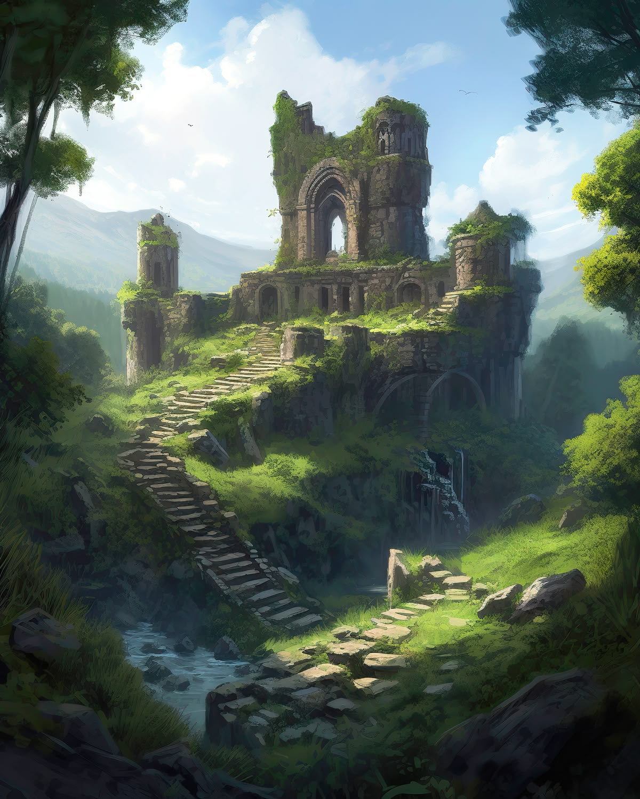

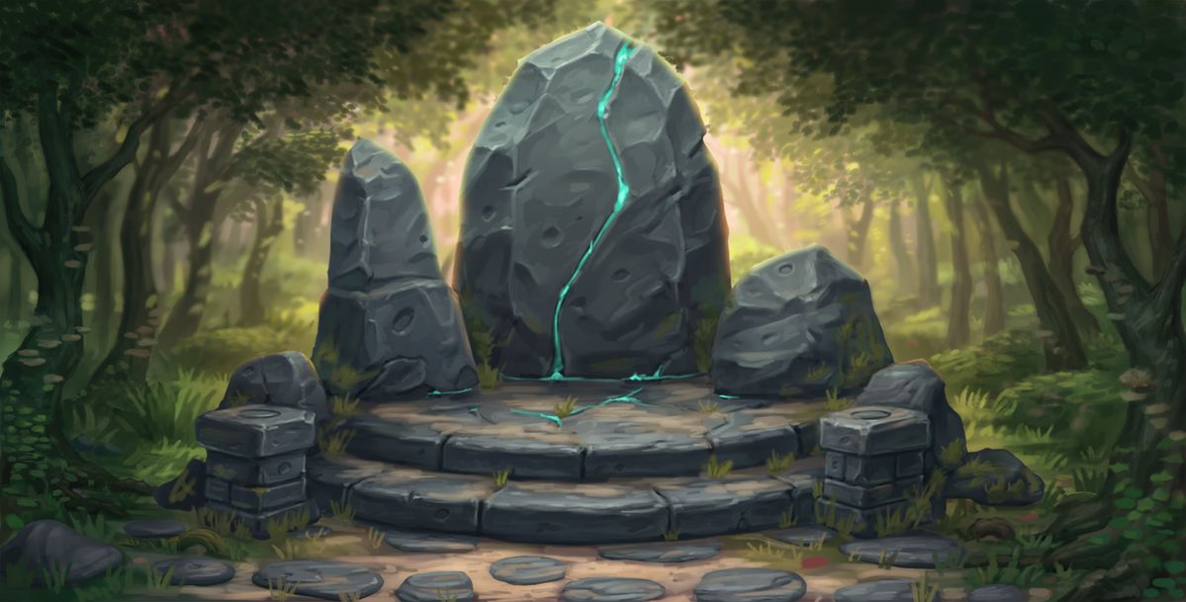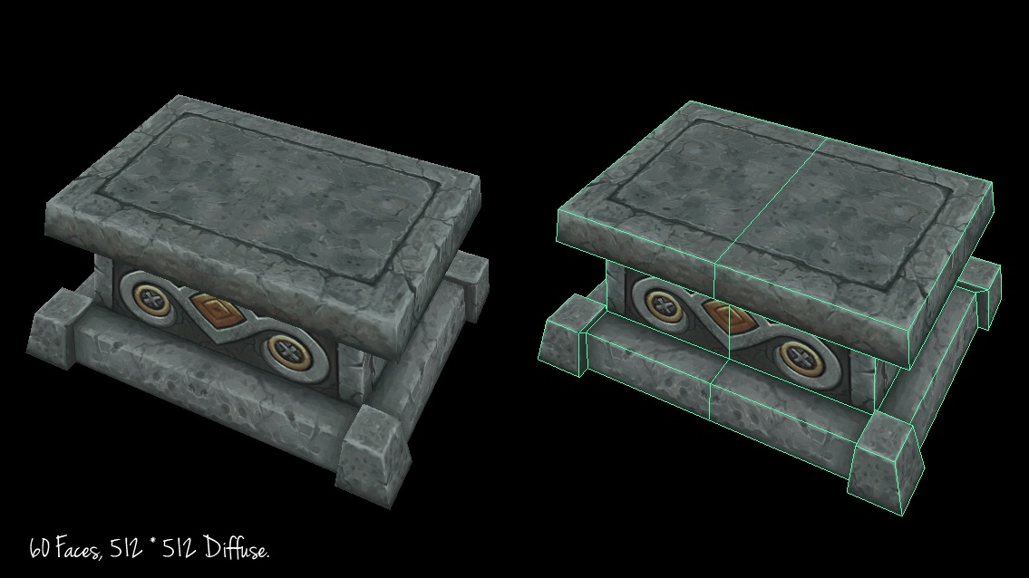

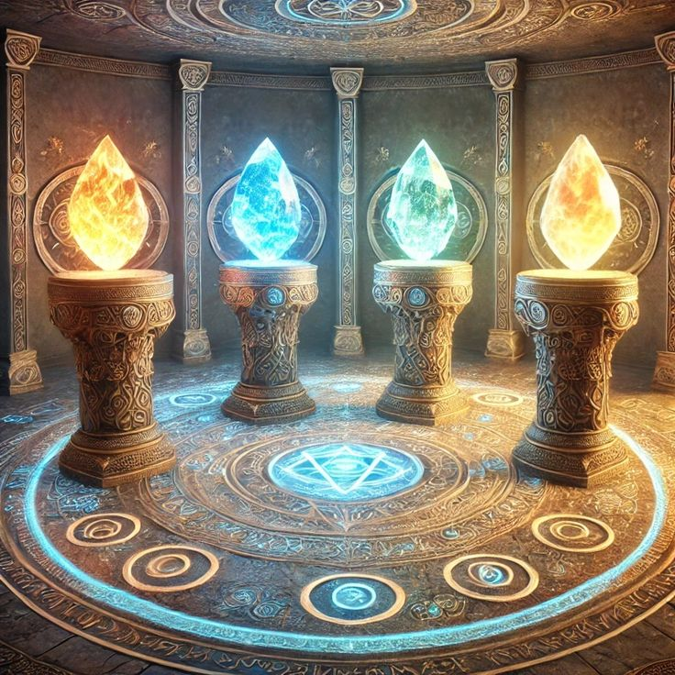

Level 3
A intro to mechanism and interactable objects, using a lever to activate the first Activated-Moving Block and a Target to activate the second one to reach a higher location.
This level uses a burning block to attract the player attention towards the Target block.

This level will take place underground in the old castle between old ruins and traps.

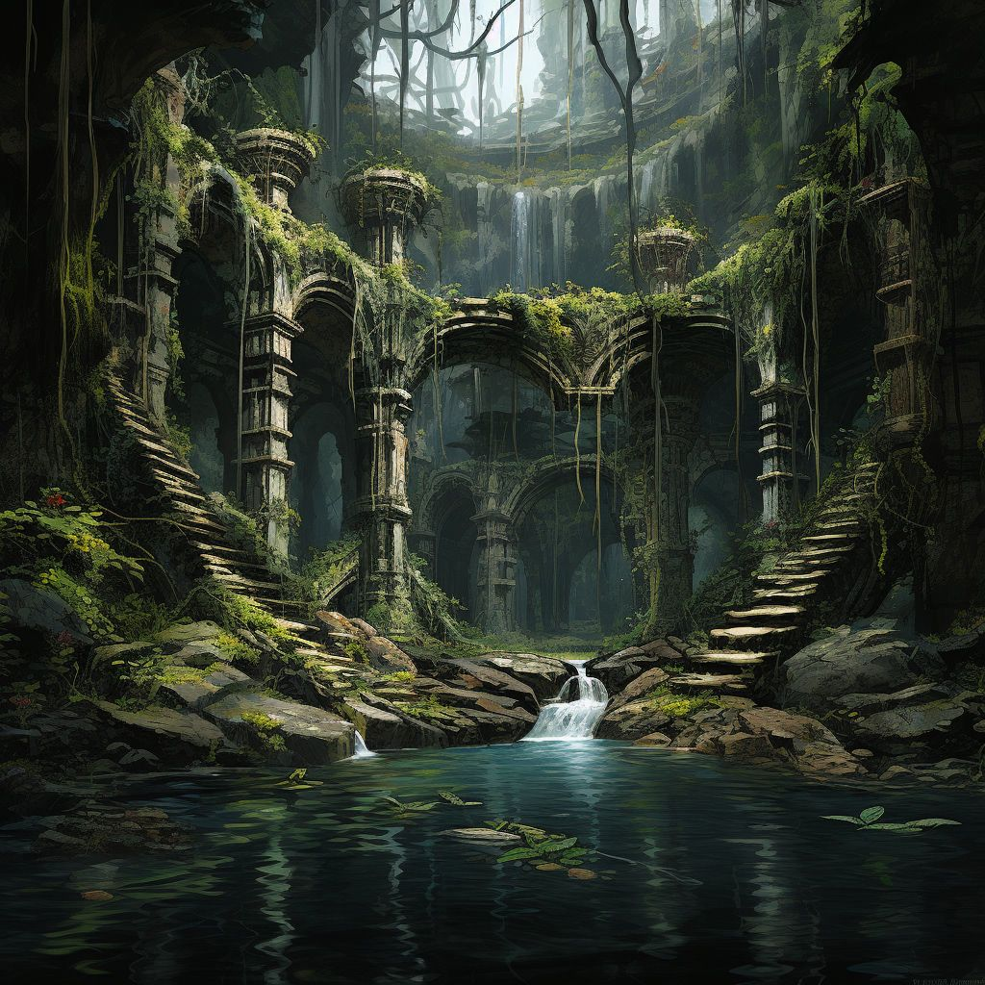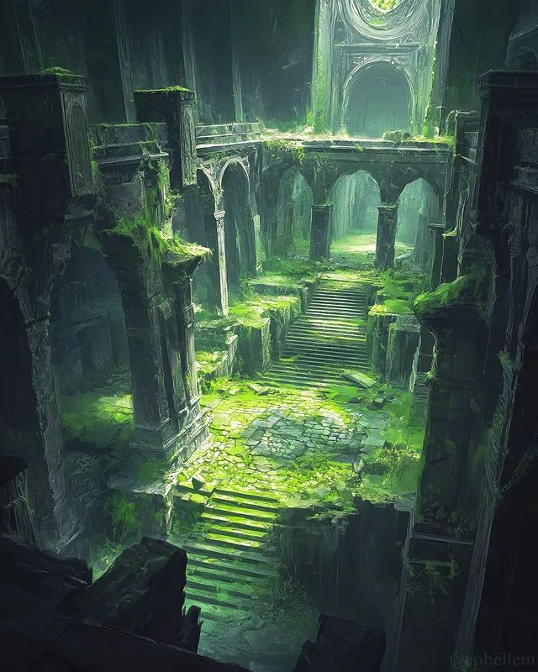

Level 4
In this level the player is introduced to elemental passives by using crumbling blocks to deliberately make the player fall into lava and not take damage, lava shod be used before this to make the player feel in danger. Small lava patches can be seen flowing through the wall and form small traps

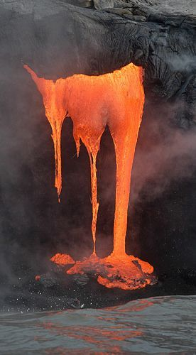

Level 5
In this level the player needs to resolve the first puzzle by stepping on the pressure plate for the platform to move and shoot at the target to make the second platform lower so that the crate can fall then on the second puzzle he needs to shoot at 3 target block one of them will activate an activate shooting arrow, while the other 2 will activate the two Activate moving blocks that block the arrow way for a short time, before returning to the original place. In front of the activate moving block will be a target block witch will move the blocks near the player spawn.

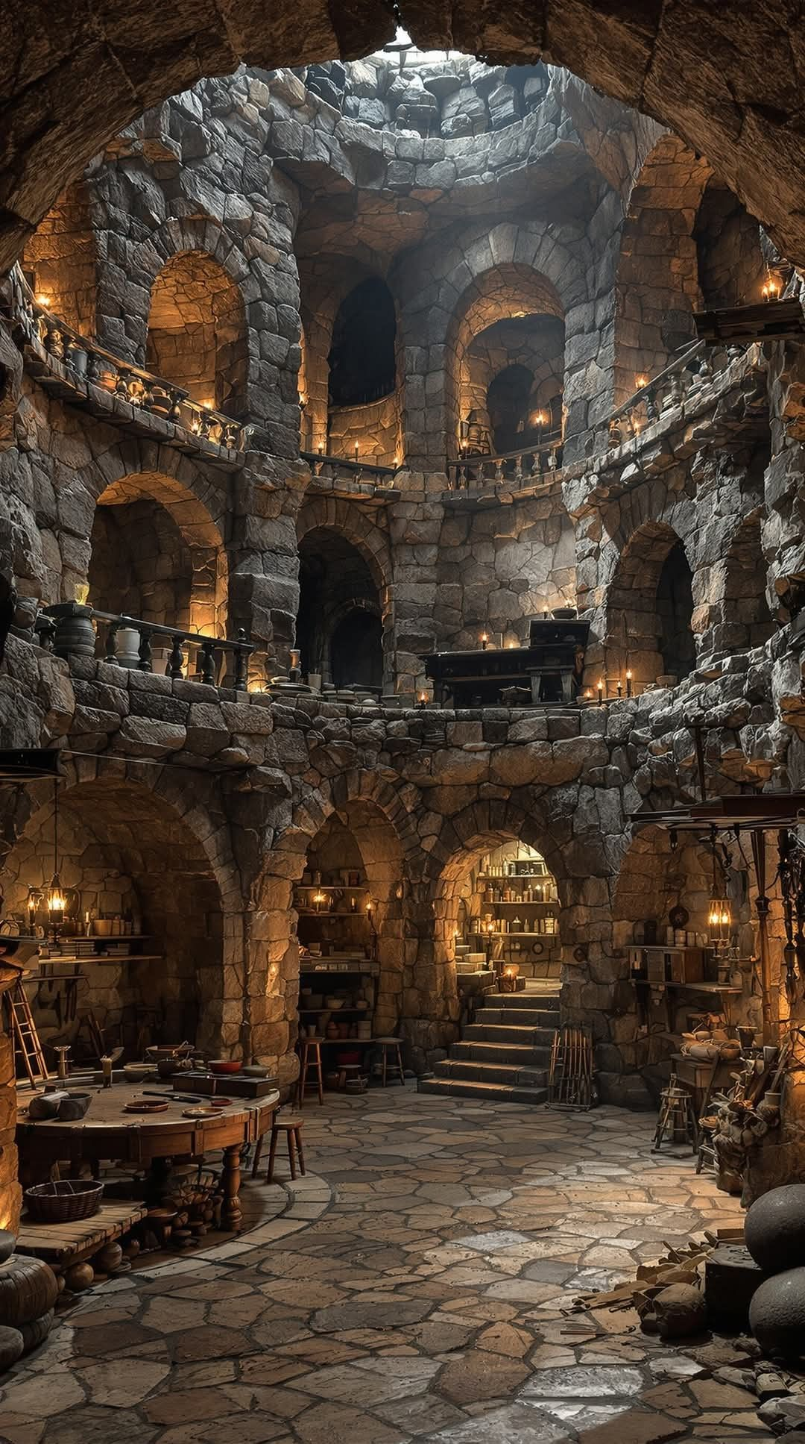

Level 6
In this level the player needs to climb and shoot at the burning blocks to open the path in front of him, he also needs to shoot at a third burning block for a crate to fall on a pressure plate that moves the activated-moving crates, if the player misses he can use a second path to reach the burning block, after that he needs to race against time to reach the activated moving block before it returns to normal while avoiding taking damage.

Level 7
This level is the transition towards the earth form, by using the puzzle in the center of the room, witch requires the player to move a crate to a second pressure plate to open the door towards the finish, first the player needs to reach the obelisk in the left side and transform, an info stone may be needed to inform the player that he has the power to move objects. In the first puzzle on the left side the player needs to synchronize his movement with the wave like activation of traps, and on the third level he needs to jump over the incoming arrows. On the right side he needs just to avoid some lava (Teaches the player that lava can now hurt him).

Level 8
In this level the player needs to resolve three main puzzles and a minor one, the player needs to push the block to the left side and use the block as a stepping stone to reach the first puzzle where he needs to avoid moving saws to reach the next puzzle where he needs to fall on crumbling blocks and avoid traps. In the third puzzle the player needs to step on the crumbling blocks to free a path for the arrow to hit the target block witch will activate two different moving platforms.

Level 9
The player needs to traverse two sets of platforms and resolve a puzzle. To traverse the first set of platforms above the lava lake the player the jump on different types of blocks and revealing/activating traps making the progression harder as the player progresses (shortcuts should be available to avoid activating traps with the effect that taking a shortcut will need a higher level of skill or by resolving a puzzle during the ascent), also some of the platforms will be retracting spikes and shooting arrows on where the player needs to time his jumps. The second challenge will be a puzzle where the player needs to move two crates above two different pressure plates, with an empty space witch the player needs to fill with an activated moving block that will be activated with a lever. After activating the two pressure plates the player can now access the second set of platforms above a lake of water where the player needs to time his jumps to avoid the retracting spikes and the arrows to reach the end point.

Level 10
The player will be spawned as the Earth fox with his first task being that of moving the mirror block and positioning it so that the fire ball can fly up and hit the target, this will make the activated moving block to come down forming a stairway to reach the higher level, then the player will need to activate the lever so that an activated moving block will move above the opening permitting the player to access the next location where the player needs to sit himself and place the crate on the Pressure plates so that the Activate mirror block moves redirecting the fire ball to burn the Plant block releasing the Mirror block witch will then be used to redirect the fire ball one last time to burn the Plant block that acts as a barrier around the obelisk. Here the player needs to transform in the Fire fox and while returning towards the beginning shoots the Target block located on the left wall above the activated moving block that will lower the wall towards the last portion. Where the player needs to shoot towards the mirror blocks, where the first mirror block redirects the fire ball towards the finish line, while the second moves an activated moving block out of the way and the third moves an Activate mirror block in front of the fire ball redirecting it towards the target. Once activated the target will move the last set of activated moving blocks out of the way.

Interface

Main Menu
Start menu is formed from main buttons such as play, levels, options, etc and secondary buttons such as music mute, audio mute, etc for a quick action.

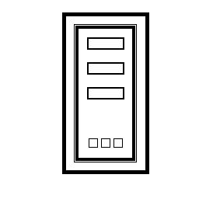

Levels
Levels will be displayed on lists, with every list having a main theme that can be found in the levels.

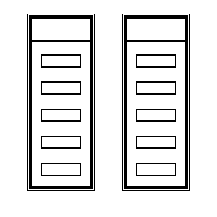

UI
The only UI present in levels will be the UI informing the player that he can interact with different objects.

Pause Menu

The pause menu will be similar with the main menu with the added option to reset the level.

Settings
In settings menu the player can modify different options, with the settings arranged in specific tabs, with the tab at the top and the individual setting shown at the bottom.

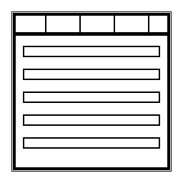

Graphics and sound

Graphics
The game uses pixel art for his graphics with a 32x32 pixel per block.

Sound
Audio will also be based on 32 bit. With 5 different music types with one for every form.
And audio effects for walk, interact, jump, landing, elemental ability(different sound for every form) and effects for different block actions.

Notite:
Jocuri to check - Greate, jack rabit, leons fortune, monuments valley

- Nivelele vor vi modificare in timpul dezvoltarii
- Mai mult game play cu fiecare personaj/putere (3-5 nivele)
- narativa si motiv
- Roll back cu puteri noi
- RLD (rational level design) – cresterea complexitatii – increase complexitatea ca beatul unei muzici from easy to hard.
- angora RLD - de verificat
- lacul elefantilor
- mai multe detalii despre nivele/ ca la programator
- story bord pe nivele x2
- lees is more

